robotics-award@ispe-dach.org

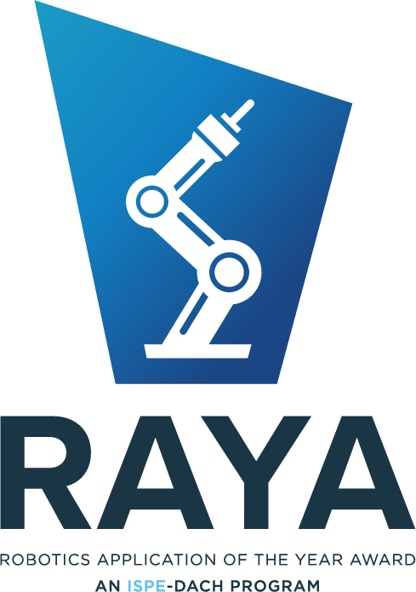
ISPE’s Robotics Applications of the Year Awards is a our annual award program that recognizes innovative applications of robotics technologies in laboratories and production sites in pharmaceutical, medtech and biotech industry.
RAYA is meant as a platform to accelerate the utilization of modern robotics in our industry. This is not only about freeing workplaces from ergonomic challenges and mindless tasks and thus making them more attractive, separating product and people even better, but also increasing availability, efficiency, and quality.
Please follow the questions in the 5 sections as well as possible in your answers so that the jury can compare the different applications, sign it in the table below and send it to robotics-award@ispe-dach.org by August 18, 2024 latest. Please send a scan as well as the electronic document (including the pictures).
All texts and pictures can be used by ISPE-DACH within the communication about RAYA. By sending this application and signing it, you declare that you are the owner of all pictures and information and agree to the publication of text and pictures.
Name of Application: __________________________________
Contact address of the leading person (who sends in the application):
___________________________________
Name of TeamMember | Name of Company | Signature

CATEGORIES
Select a category which fits your application best. In case of difficulties, you are allowed to optionally select a second category. In that case the jury will judge in which category your application fits best.
Mark your selection by underlining it within the following table:
QC Laboratories | Fill & Finish | Logistics
R&D Laboratories | Drug Substance / API | Packaging & Final assembly
Drug Product | BioTech | MedTech
Best innovative technical concept across all categories
The above categories refer to installed applications only (see requirements section 5). If you want to apply with an application which is not installed yet (e.g. technical demonstrator) you can apply to be awarded a price for the
“best innovative technical concept across all categories”. In this case mark this category only.
All proposals of any category compete in “Best innovative technical concept across all categories” automatically, independently from the state of implementation.
If no applications are submitted in a category or if the quality of the submitted applications is not sufficient in the opinion of the jury, no award will be given in this category.

PROCESS
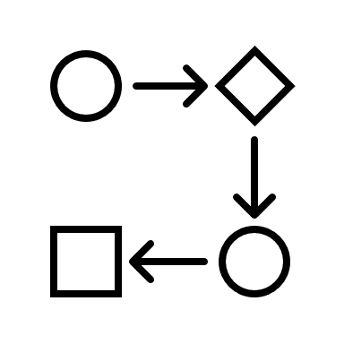
Describe the process in this chapter automated by your application. Please name the physical input and output of the application and the process itself – all illustrated by meaningful pictures. Please reflect the name of the Award: It is about “robotics”. Therefor the robot should be a major enabler within your application. This role must become clear within your description of the application.
Description of Input (all objects anyhow handled by automation in scope):
Meaningful Pictures of all objects

EVALUATION OF ROBOTICS APPLICATION (5 criterias)
Describe your application in 5 sections according to the 5 evaluation criteria allow the jury to compare your application to other applications in the same category in each criteria.

Each concept or application is evaluated based on the below mentioned criterias. Please reflect the name of the Award: It is about “robotics”. Therefor the robot should be a major enabler within your application. This role must become clear within your description of the application.
Within 1st priority we are focusing on the attractiveness of the applications and would like additional information to support a strong use-case and teaser describing the concept/application supported by quantified business drivers within the following areas impacted: Ergonomics, Improved Process Quality, Efficiency, 24/7 availability, Aseptic conditions, Human protection, Sustainability.
Please describe here the attractiveness of your application from the point of view of the applying industry.

2) Second priority is the economic potential of your application. Such calculations require assumptions which are sometimes difficult to judge – anyhow you will earn points in this category if and only if you present an argumentation based on reasonable assumptions. Finally, you must select one out of the four following “Return of investment” categories supported by your argumentation:
< 1 year; < 3 year; < 5 years; > 5 years
Describe your argumentation of the economic potential here and name the selected ROI category

3) Third priority is attractiveness to be applied across pharma.
In order to convince the jury, you have to provide an overview about the area within pharmaceutical industry where your application can be used in production plants and laboratories.
Describe the target area in pharma for your application here and explain why this area fits to your application

4) Fourth priority is the flexibility of your application. The jury will value it if your automation comes with built-In adaptability. Examples are automated features for format change over, line clearance, adoption to product, built-in cleaning procedures or simplicity of re-qualification.
Describe the flexibility of your application here and explain the built-in features leading to the flexibility.

5) Fifth priority is the easiness to integrate. We ask you to describe the effort of deploying your application to other customers. Categorize your application according to the five following options and describe for your arguments:
- Plug & Play: Anyone can buy it including qualification, apply without customization
- Anyone can buy it, apply without customization, but requires qualification
- Applicable with relevant customization (to be described)
- Concept is transferable but engineering must be adopted
- Concept is transferable but re-design necessary

Name the option selected by you for your application here and explain why your application belongs to this category.

RESTRICTIONS
- Automation of manual/physical tasks
(no software application only / no RPA)
- Robot centric automation
  - Mobile robotics is included in RAYA
  - But no classic machinery without a robot at all
- Readiness level: (TRL 6 or 7)
  - Minimum one installed pilot
  - installed in the intended environment
(manufacturing site / R&D site)
  - safety certification started
  - qualified or qualification scheduled
- Applicable within pharmaceutical industry
- There are no regional restrictions: Applications can include robotics applications from anywhere in the world!“

You need not answer again to the restrictions 1, 2, 4 and 5, but please describe why your application fulfills all parts of requirement 3 here.

